Natural Gas Highlights

- Gulf South received authorization for its Parks Line Upgrade and Sorrento Station Project, including replacing 4.5 miles of various segments of its Line 330, increasing the line to its full 1,000 psi pressure, and constructing the 12,510 HP Sorrento Compressor Station on its line 270. The project, in St. Martin and Ascension Parishes, LA, would add 236 MMcf/d of new capacity for electric generation and for LDC customers.
- NGPL received authorization for its Gulf Coast Storage Expansion Project at its Lansing Storage Field in Harrison County, TX. The project, supported by four shippers, includes a 12,000 HP compressor and 5.9 miles of new pipeline, and would increase the field capacity by 10 BCF and deliverability by 200 MMcf/d.
- Florida Gas received authorization for its Madison Lateral MAOP Reduction Project, consisting of reducing the MAOP on the lateral from 975 to 850 psig. The project, in Lafayette and Madison Counties, FL, is needed for compliance with PHMSA's regulations and to increase operational efficiencies.
- West Texas Gas Utility's NGA Section 3 Authorization was transferred to Texas Pipeline Exports. The transfer is needed because of the sale of the relevant facilities to Texas Exports.
- Mountain Valley's Southgate Project was amended to reduce the H-650 pipeline by 42-miles, eliminate the 28,915 HP Lambert CS, and increase pipeline capacity from 375 to 550 MMcf/d. The project extends from Pittsylvania County, VA to Rockingham County, NC.
- Texas Eastern received authorization for its Longwall Mining Panel M1 Project in Green County, PA, including replacing a total of 5.2 miles of pipeline segments on four separate lines in order to accommodate longwall mining activities.
- Golden Pass LNG received authorization to amend its certificate in order to construct a 1.1-mile pipeline lateral within its LNG terminal. The Project would provide supply diversification by connecting to the Trident Interstate and Kinder Morgan Louisiana Pipelines.
- Forza Pipeline and Bull Run Pipeline request authorization to construct 35.9 miles of new pipeline extending from the new Desert Ram Junction in Lea County, NM, to the Wildcat Junction in Winkler County, TX, a meter station and a new mainline valve in Loving County, TX, to lease 750 MMcf/d of natural gas transportation on the Bull Run Pipeline. Bull Run requests a limited jurisdiction certificate authorizing it to provide jurisdictional transportation service under the lease agreement without affecting the non-jurisdictional status of any other of its operations or services.
- Transco requests authorization for its Project Facilities Relocation, including removal and relocation of approximately .01-mile of pipe, and removal and installation of related facilities in Hudson County, NJ. The project is needed to accommodate Amtrak's Sawtooth Project.
- Northern Natural requests authorization for its Columbus Branch Line Replacement Project, including replacing a 7.5-mile segment of its NEB52901 line, and uprating the MAOP on a segment of its Columbus Branch Line, all in Platte and Colfax counties NE. The project would enhance safety, security and operational efficiency of Northern's system.
- Southern Star Central requests authorization to replace the glycol reboiler system at its McLough Storage Compressor Station in Jefferson County, KS. The project would replace ageing dehydration equipment and address reliability, safety and compliance needs at the station.
- NGPL requests authorization for its Texas-Arkansas Project, including installing two gas compressor units and abandoning nine units at its CS 308 in Randolph County, AR, and making the CS bi-directional. The project would increase firm capacity by 268 MMcf/d to serve power generators in AR and TX.
- Columbia Gas requests authorization for its Casey Creek Project, which consists of abandoning by removal and in place 0.5 miles of pipe and replacing it with 0.51 miles of pipe. The project, in Adair County, KY, is needed to mitigate creek erosion risks.
- Columbia Gas requests authorization for its Line A90 and A79 Make Piggable Project, including installing bi-directional launcher-receiver stations at its Crawford Compressor Stations and its Howell Meter Station, located in Fairfield and Greene Counties, OH respectively; and other related activities in Madison and Pickaway Counties, OH. The project would support ongoing monitoring and maintenance activities and would not impact customers or pipeline parameters.
- Texas Eastern requests authorization for certain alternative measures for its Line 40 LAR-WHCA Replacement Project in Lafourche County, LA.
- Creole Trail requests authorization for its Gillis Header Project, including construction of an extension of the Gillis CS natural gas suction and discharge headers in Beauregard Parish, LA. The project would provide redundancy and optimization of the pipeline system.
- Constitution Pipeline filed a Petition for reissuance of Certificate Authority and Reaffirmance of Waiver Determination regarding the expired certificate for its Constitution Pipeline.
- Clarksville Gas and Water requests a service area determination within which it may expand its natural gas distribution facilities without further Commission authorization. This would allow it to operate a 25-foot pipeline across the Tennessee-Kentucky border in order to interconnect with facilities in KY.
- Corpus Christi Liquefaction requests authorization for its CCL Midscale Uprate, which would increase LNG production capacity at its Texas terminal by 0.69 MMcf/d. The uprate does not involve new or additional construction and reflects refinements and optimizations made during construction.
- Eastern Gas Transmission and Storage requests authorization to install horizontal I/W Well No. UW-211 and related pipe and tie-in facilities at its North Summit Storage Field in Fayette County, PA. The project would not change the field's certificated parameters but would optimize the capabilities at the field.
- National Fuel requests authorization for its Line CS46S 2026 Modernization Project, including replacing 2.86-miles of pipe at its Colden Storage Field in Erie County, NY. The project would replace older sections of pipeline as part of efforts to continue to provide safe and reliable services.
- Southern Star Central requests authorization to replace the glycol reboiler system at its McLough Storage Compressor Station in Jefferson County, KS. The project would replace ageing dehydration equipment and address reliability, safety and compliance needs at the station.
- Columbia Gas requests authorization for its Medina New Drills Project, including drilling two I/W wells and associated storage field pipelines and appurtenances at its Medina Storage Field in Medina County, OH. The project would maintain overall field performance.
- Egan Hub Storage requests authorization for its Egan Cavern Expansion Project, which includes constructing caverns No. 6 and No. 7, three compressors with 16,500 HP of new compression, one new fresh water well and one salt disposal well, and other facilities at its Egan Gas Storage Facility in Acadia Parish, LA. The project would increase working gas capacity by 16 Bcf, injection capacity by 510 MMcf/d, and would help achieve a design withdrawal capacity of 2,700 MMcf/d.
- Columbia Gas requests authorization for its 2026 Holmes-Weaver Project, including abandoning Well 6111 and related facilities at its Weaver Storage Field in Richland County, OH; and abandon Well 10507 and related facilities and convert Well 10474 to an observation well at its Homes Storage field in Holmes County, OH. The project would not impact storage parameters and is needed to comply with PHMSA's Storage Final Rule.
- Southern Star Central requests authorization to drill a new horizontal well, Well No. 55-H, at its Webb Storage Field in Grant County, OK, and related pipelines, pigging equipment, and related facilities. The project would enhance deliverability, improve efficiency and reduce operating costs, and would not change the certificated parameters of the fields.
- Texas Gas requests authorization for its Midland Delta Pressure Project, which consists of increasing the pressure capacity at its Midland Gas Storage Field in Muhlenberg County, KY, from 927 to 977 psi. The project would increase the field's working gas capacity by 8.7 Bcf.
- Boardwalk Storage requests to abandon certain certificated storage capacity at its storage Cavern 25 at its Choctaw Gas Storage Facility in Iberville Parish, LA. Boardwalk requests to amend the certificated capacity of the facility from 11.8 to 9.55 Bcf, or from 7.6 to 6.16 Bcf of working gas. The reduction would not affect injection or deliverability and would align with the cavern's current physical capabilities.
- Venture Global Plaquemines requests and amendment to the authorization for its Plaquemines LNG terminal, to increase the authorized peak liquefaction capacity from 1,405.33 to 1,875 Bcf/y. The increase would reflect the actual achievable peak liquefaction and would not involve any new construction.
- Venture Global CP2 requests and amendment to the authorization for its CP2 LNG terminal, to increase the authorized peak liquefaction capacity from 1,446 to 1,873 Bcf/y. The increase would reflect the actual achievable peak liquefaction and would not involve any new construction.

Natural Gas Activity - December 2025
Status | No. of Projects | Storage Capacity (Bcf) | Deliverability (MMcf/d) | Capacity (MMcf/d) | Miles of Pipeline | Compression (HP)
Pipeline
Placed in Service | 0 |  |  | 0 | 0 | 0
Certificated | 3 |  |  | 371 | 168 | -4,405
Proposed | 5 |  |  | 1,018 | 44 | 40,946
Storage
Placed in Service | 0 | 0.0 | 0.0 |  |  | 0
Certificated | 0 | 0.0 | 0.0 |  |  | 0
Proposed | 4 | 24.7 | 0.7 |  |  | 16,500
LNG (Import & Export)
Placed in Service (Export) | 0 | 0.0 | 0.0 |  |  | 0
Certificated (Import/Export) | 1 | 260.0 | 1.1 |  |  | 0
Proposed (Import/Export) | 1 | 0.0 | 2.5 |  |  | 0
Source: FERC E-Library

Natural Gas Activities through December 31, 2025
January through December 31, 2024
Status | No. of  Projects | Storage Capacity  (BCF) | Deliverability (MMcf/d) | Capacity (MMcf/d) | Miles of Pipeline | Compression (HP)
Pipeline
Placed in Service | 17 |  |  | 2,921.1 | 207.7 | 342,856
through December 31, 2024 | 18 |  |  | 8,969 | 530 | 495,958
Certificated | 30 |  |  | 2,603.1 | 360.2 | 128,619
through December 31, 2024 | 35 |  |  | 10,994 | 268 | 609,867
Storage
Placed in Service | 0 | 0.0 | 0.0 |  |  | 0
through December 31, 2024 | 3 | 23 | 450 |  |  | 35,100
Certificated | 2 | 34.9 | 1,050.0 |  |  | 33,500
through December 31, 2024 | 5 | 30 | 965 |  |  | 33,000
LNG (Import & Export)
Placed in Service (Export) | 1 | 0.0 | 0.0 |  |  | 0
through December 31, 2024 | 0 | 0 | 0 |  |  | 0
Certificated (Import/Export) | 3 | 260.0 | 920.1 |  |  | 0
through December 31, 2024 | 2 | 1 | 4 |  |  | 0
Source: FERC E-Library
Hydropower Highlights (nonfederal)

- PacifiCorp has filed for a 10 MW Exemption for the 7.6 MW Ashton Hydroelectric Project No. 2381. The project is located on the Henry’s Fork of the Snake River in Fremont County, ID.
Hydropower Project Activities December 2025
Status | Conventional |  | Pumped Storage |  | Hydrokinetic |  | Total No. of Projects | Total Capacity (MW)
Status | No. | Capacity (MW) | No. | Capacity (MW) | No. | Capacity (MW) | Total No. of Projects | Total Capacity (MW)
Filed
License | 0 | 0 | 0 | 0 | 0 | 0 | 0 | 0
10-MW Exemption | 1 | 7.600 | 0 | 0 | 0 | 0 | 1 | 7.600
Capacity Amendment | 0 | 0 | 0 | 0 | 0 | 0 | 0 | 0
Conduit Exemption | 0 | 0 | 0 | 0 | 0 | 0 | 0 | 0
Issued
License | 0 | 0 | 0 | 0 | 0 | 0 | 0 | 0
10-MW Exemption | 0 | 0 | 0 | 0 | 0 | 0 | 0 | 0
Capacity Amendment | 0 | 0 | 0 | 0 | 0 | 0 | 0 | 0
Conduit Exemption | 0 | 0 | 0 | 0 | 0 | 0 | 0 | 0
Placed in Service
License | 0 | 0 | 0 | 0 | 0 | 0 | 0 | 0
10-MW Exemption | 0 | 0 | 0 | 0 | 0 | 0 | 0 | 0
Capacity Amendment | 0 | 0 | 0 | 0 | 0 | 0 | 0 | 0
Conduit Exemption | 0 | 0 | 0 | 0 | 0 | 0 | 0 | 0
Source: FERC E-Library

Hydropower Project Activities Year to Date (through December 31, 2025)
Status | Conventional |  | Pumped Storage |  | Hydrokinetic |  | Total No. of Projects | Total Capacity (MW)
Status | No. | Capacity (MW) | No. | Capacity (MW) | No. | Capacity (MW) | Total No. of Projects | Total Capacity (MW)
Filed
License | 2 | 29.296 | 2 | 708.000 | 0 | 0 | 3 | 737.296
10-MW Exemption | 1 | 7.600 | 0 | 0 | 0 | 0 | 1 | 7.600
Capacity Amendment | 6 | 15.370 | 1 | 225.000 | 0 | 0 | 7 | 240.370
Conduit Exemption | 0 | 0 | 0 | 0 | 0 | 0 | 0 | 0
Issued
License | 0 | 0 | 0 | 0 | 0 | 0 | 0 | 0
10-MW Exemption | 0 | 0 | 0 | 0 | 0 | 0 | 0 | 0
Capacity Amendment | 4 | 2.750 | 0 | 0 | 0 | 0 | 4 | 2.750
Conduit Exemption | 0 | 0 | 0 | 0 | 0 | 0 | 0 | 0
Placed in Service
License | 0 | 0 | 0 | 0 | 0 | 0 | 0 | 0
10-MW Exemption | 0 | 0 | 0 | 0 | 0 | 0 | 0 | 0
Capacity Amendment | 0 | 0 | 0 | 0 | 0 | 0 | 0 | 0
Conduit Exemption | 0 | 0 | 0 | 0 | 0 | 0 | 0 | 0

Source: FERC E-Library
Electric Generation Highlights

- Top Hat Wind Energy LLC’s 200.0 MW Top Hat Wind Energy Center in Logan County, IL is online.
- Iron Pine Solar Power LLC’s 325.0 MW Iron Pine Solar Project in Pine County, MN is online.
- Morrow Lake Solar LLC’s 201.1 MW Morrow Lake Solar & Storage Project in Frio County, TX is online.
- CPV Backbone Solar LLC‘s 160.0 MW CPV Backbone Solar Project in Garrett County, MD is online.
- Sycamore Creek Solar LLC’s 117.0 MW Sycamore Creek Solar Project in Crawford County, OH is online.
- Origis Energy’s 74.9 MW Whistling Duck Solar Project in Levy County, FL is online.
- Genesee Solar Energy LLC’s 40.8 MW Genesee Solar Project in Genesee County, MI is online. The power generated is sold to Consumers Energy Co under long-term contract.
- LeGore Bridge Solar Center LLC’s 20.0 MW LeGore Bridge Solar Center in Frederick County, MD is online.
- Walden Renewables LLC’s 20.0 MW Mousam River Solar Project in York County, ME is online.
- BQ Energy’s 8.8 MW solar powered Yeoman Creek Project in Lake County, IL is online.
- SPME Solport 2024 LLC’s 6.4 MW solar powered Synergen Panorama III Project in Harford County, MD is online.
- Lincoln KA32 Solar LLC’s 5.0 MW Lincoln Ka32 Solar Project in Kankakee County, IL is online.
Sources: Data derived from Velocity Suite, Hitachi Energy and Yes Energy. The data may be subject to update.
*“Other” includes purchased steam, tires, and miscellaneous technology such as batteries, fuel cells, energy storage, and fly wheel.

New Generation In-Service (New Build and Expansion)
 | December 2025 |  | January – December 2025 Cumulative |  | January – December 2024 Cumulative
Primary Fuel Type | No. of Units | Installed Capacity (MW) | No. of Units | Installed Capacity (MW) | No. of Units | Installed Capacity (MW)
Coal | 0 | 0 | 3 | -40 | 1 | 13
Natural Gas | 0 | 0 | 84 | 4,179 | 122 | 2,640
Nuclear | 0 | 0 | 0 | 0 | 4 | 1,100
Oil | 0 | 0 | 14 | 66 | 22 | 38
Water | 0 | 0 | 1 | 4 | 4 | 213
Wind | 1 | 200 | 36 | 5,763 | 34 | 4,581
Biomass | 0 | 0 | 3 | 6 | 7 | 53
Geothermal Steam | 0 | 0 | 0 | 0 | 2 | 29
Solar | 17 | 993 | 710 | 26,556 | 918 | 33,863
Waste Heat | 0 | 0 | 4 | 17 | 7 | 27
Other * | 6 | 0 | 194 | 0 | 217 | 30
Total | 24 | 1,193 | 1,049 | 36,551 | 1,338 | 42,587

Sources: Data derived from Velocity Suite, Hitachi Energy and Yes Energy. The data may be subject to update.
*“Other” includes purchased steam, tires, and miscellaneous technology such as batteries, fuel cells, energy storage, and fly wheel.

Total Available Installed Generating Capacity

 | Installed Capacity (GW) | % of Total Capacity
Coal | 193.40 | 14.29%
Natural Gas | 570.56 | 42.17%
Nuclear | 104.39 | 7.71%
Oil | 36.40 | 2.69%
Water | 102.09 | 7.54%
Wind | 161.10 | 11.91%
Biomass | 14.19 | 1.05%
Geothermal Steam | 4.20 | 0.31%
Solar | 164.53 | 12.16%
Waste Heat | 1.34 | 0.10%
Other | 0.84 | 0.06%
Total | 1,353.04 | 100.00%
Sources: Data derived from Velocity Suite, Hitachi Energy and Yes Energy. The data may be subject to update.

Generation Capacity Additions and Retirements
(January 2026 – December 2028)
From Hitachi Energy Velocity Suite’s Generating Unit Capacity Dataset

 | All Additions |  | High Probability Additions |  | Retirements
Primary Fuel Type | No. of Units | Installed Capacity (MW) | No. of Units | Installed Capacity (MW) | No. of Units | Installed Capacity (MW)
Coal | 1 | 35 | 0 | 0 | 75 | 40,828
Natural Gas | 283 | 51,252 | 152 | 22,778 | 97 | 14,624
Nuclear | 2 | 335 | 2 | 335 | 0 | 0
Oil | 13 | 819 | 6 | 37 | 32 | 1,627
Water | 142 | 9,543 | 45 | 584 | 13 | 30
Wind | 223 | 64,839 | 65 | 19,991 | 13 | 170
Biomass | 37 | 298 | 16 | 138 | 23 | 254
Geothermal Steam | 15 | 575 | 3 | 102 | 0 | 0
Solar | 3,023 | 240,567 | 979 | 86,541 | 20 | 415
Waste Heat | 8 | 73 | 5 | 40 | 0 | 0
Other * | 1,287 | 6 | 373 | 1 | 3 | 0
Total | 5,034 | 368,342 | 1,646 | 130,547 | 276 | 57,948
Sources: Data derived from Velocity Suite, Hitachi Energy and Yes Energy. The data may be subject to update.
* “Other” includes purchased steam, tires, and miscellaneous technology such as batteries, fuel cells, energy storage, and fly wheel.
** Under Constructions includes units that have started site preparation or construction. It also includes units that are in the testing phase.

Electric Transmission Highlights

- Central Maine Power has completed the 26.0 mi, 345 kV Coopers Mills - Maine Yankee Transmission Project in ME.
- ITC Michigan has completed the 4.0 mi, 345 kV Murphy – Orr Road Transmission Project in MI.
- Cheyenne Light, Fuel and Power Company has completed the interstate Ready Wyoming Electric Transmission Expansion Project connecting WY to NE. The project includes 249.4 miles, 230 kV Windstar – West Cheyenne – Sweetgrass – Bluffs Transmission Project.
- East Texas Electric Cooperative has completed the 15.0 mi, 138 kV Fred Substation – Fred Switching Station Transmission Project in TX.
- Nebraska Public Power District has completed the 7.5 mi, 115 kV Norfolk – Stanton North Transmission Project in NE.
- Northern States Power Company has completed the 6.0 mi, 115 kV Umore Park – Inver Grove Transmission Project in MN.

 | Transmission Projects Completed |  |  |  | Proposed Transmission Projects  In-Service by May 2028
Voltage (kV) | December2025 | December 2024 | January – December 2025 Cumulative | January – December 2024 Cumulative | High Probability of Completion |  | All
Voltage (kV) | Line Length (miles)
≤230 | 277.9 | 46.2 | 380.3 | 791.3 | 839.0 | 1,039.0
345 | 30.0 | 0.0 | 400.8 | 352.1 | 727.7 | 891.7
500 | 0.0 | 0.0 | 1.8 | 554.0 | 271.7 | 271.7
Total U.S. | 307.9 | 46.2 | 782.9 | 1,697.4 | 1,838.4 | 2,202.4
Sources: North American Electric Reliability Corporation (NERC) Electricity Supply & Demand (ES&D) and U.S. Electric Transmission Projects © Yes Energy The C Three Group, LLC.

All Transmission Projects with a Proposed In-Service Date by May 2028
Transmission Projects with a High Probability of being completed by May 2028

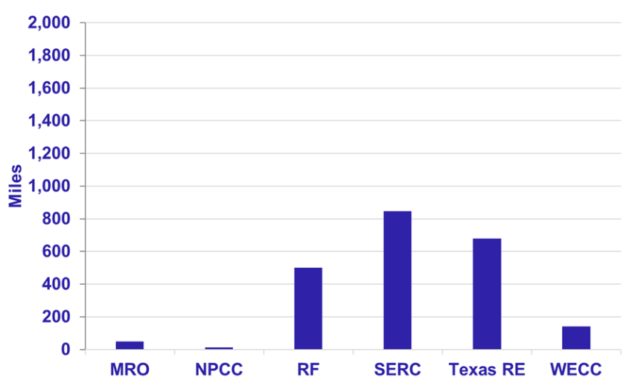
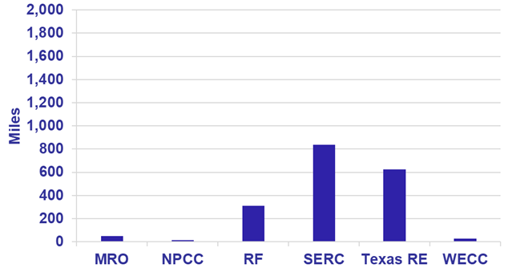

New Transmission Projects by Voltage

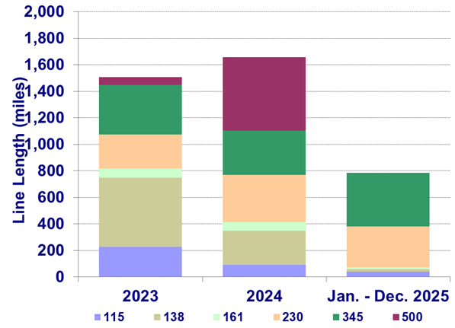

Sources: North American Electric Reliability Corporation (NERC) Electricity Supply & Demand (ES&D) and U.S. Electric Transmission Projects © Yes Energy The C Three Group, LLC.

Disclaimer: This Report contains analyses, presentations, and conclusions that may be based on or derived from the data sources cited, but do not necessarily reflect the positions or recommendations of the data providers.

