UNITED STATES OF AMERICA
FEDERAL ENERGY REGULATORY COMMISSION

Improving Winter-Readiness of Generating Units | Docket No. AD22-4-000

SUPPLEMENTAL NOTICE OF TECHNICAL CONFERENCE

(March 10, 2022)

As announced in the Notice of Technical Conference issued in this proceeding on November 18, 2021, the Federal Energy Regulatory Commission (Commission) will convene a Joint Technical Conference with the North American Electric Reliability Corporation (NERC) and the Regional Entities in the above-referenced proceeding on Wednesday, April 27 and Thursday, April 28, 2022 from approximately 11:00 a.m. to 5:00 p.m. Eastern time each day. The conference will be held virtually via WebEx.

The purpose of this conference is to discuss how to improve the winter-readiness of generating units, including best practices, lessons learned and increased use of the NERC Guidelines, as recommended in the Joint February 2021 Cold Weather Outages Report.

The conference will be open for the public to attend electronically. Registration for the conference is not required and there is no fee for attendance. To join the conference, go to the web Calendar of Events for this event on FERC’s web site, www.ferc.gov. The link for the event will be posted at the top of the calendar page and will “go live” just prior to the conference start time. The conference will also be transcribed. Transcripts will be available for a fee from Ace Reporting, (202) 347-3700.

Those who wish to nominate their names for consideration as a panel participant should submit their name, title, company, (or organization they are representing), telephone, email, a one-paragraph biography, picture, and topic they wish to address, to WinterReadiness2022@ferc.gov by close of business on Friday, March 25, 2022.

Commission conferences are accessible under section 508 of the Rehabilitation Act of 1973. For accessibility accommodations, please send an e-mail to accessibility@ferc.gov, call toll-free (866) 208-3372 (voice) or (202) 208-8659 (TTY), or send a fax to (202) 208-2106 with the required accommodations.

For more information about this technical conference, please contact Lodie White at Lodie.White@ferc.gov or (202) 502-8453. For information related to logistics, please contact Sarah McKinley at Sarah.Mckinley@ferc.gov or (202) 502-8368.

Kimberly D. Bose,
Secretary.

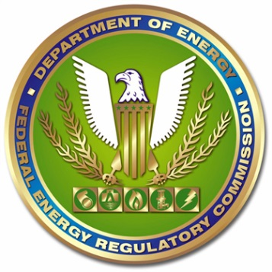

Improving Winter-Readiness of Generating Units Technical Conference
Docket No. AD22-4-000
Wednesday, April 27 and Thursday, April 28, 2022
11:00 a.m. – 5:00 p.m.

DAY ONE
Panel 1: Cold Weather Preparedness Plans
Panelists will discuss Generator Owner and Generator Operator best practices for cold weather preparedness plans.

Panel 2: Planning, Engineering and Technologies for Cold Weather Preparedness
Panelists will discuss newer technologies that could improve cold weather preparedness of existing plants or in planning of future projects.

DAY TWO

Panel 3: Implementing Cold Weather Preparedness Plans for Reliable Operations
Panelists will discuss ongoing measures for winter preparedness and operations to ensure reliability.

Panel 4: Communications, Coordination, Training, and Education for Cold Weather Operations
Panelists will discuss communication and coordination in advance of and during extreme cold weather events.

See The February 2021 Cold Weather Outages in Texas and the South Central United States - FERC, NERC and Regional Entity Staff Report at pp 18, 192 (November 16, 2021), https://www.ferc.gov/news-events/news/final-report-february-2021-freeze-underscores-winterization-recommendations

