Submission of Dr. Anna Scott, Co-Founder and Chief Science Office
Project Canary with regards to Technical Conference on Greenhouse Gas Mitigation: Docket No. PL21-3-000

Executive Summary

The U.N. Intergovernmental Panel on Climate Change released a major new report in August 2021 revealing the planet was warming quicker than expected, but that there is still a window in which humans can alter the climate path. The five “climate futures” laid out all required quick actions to cut carbon today, in addition to longer-term actions.

This U.N. report underscores the market opportunity for quick carbon wins today as businesses and consumers join with governments and scientists to demand less carbon-intensive energy sources.

Not all climate solutions can be instituted immediately. Building large scale, zero-carbon energy projects—and the transmission lines to deliver that power—takes time to finance, permit and execute, in some cases as long as a decade. And because climate is not the only environmental challenge society faces, impacts on water use, land use and local communities mean that some climate solutions simply don’t check all the environmental, social and governance (ESG) boxes.

All of this means quick climate wins that pass a high ESG bar are imperative.

One approach is to focus on the high-intensity greenhouse gas methane. Methane emissions and leaks are pervasive but highly variable in the natural gas supply chain, in which the carbon intensity has historically been underestimated because many of those emissions are poorly counted due to inadequate monitoring and data collection.

Methane emission reductions represent a unique opportunity to lower carbon emissions through responsibly sourced natural gas. The U.N. Global Methane Assessment found that readily available targeted control measures can eliminate more than 30 percent of projected anthropogenic methane emissions this decade.

Natural gas has long been considered as a standardized commodity, even though there are large differences in environmental impacts resulting from differing approaches to operational practices and engineering investments.

At Project Canary, we believe that one solution amongst a suite of climate solutions is an independent certification program for the energy supply chain that doesn’t only verify that a company’s operations meet regulatory standards, but rather one that incentivizes firms to go above and beyond minimum requirements in order to deliver environmental returns for society.
Gas product differentiation through an independent certification process offers many benefits to end-use buyers, including an important quick climate win while more complex clean energy solutions take time to develop and implement.
Project Canary has a certification program that allows for this differentiation. Key to this certification process is an engineering-based review process that assesses development through to operations as well as continuous monitoring of emissions along the supply chain. While our certification examines how these factors may impact air, water, land and/or community, a few key engineering components that affect emissions include:
  - Operational venting or flaring
  - Electrification of facilities and equipment
  - Low bleed and/or zero bleed process controls
  - Leak detection and repair (LDAR) programs
  - Produced water treatment and reuse
  - Infrastructure and facility efficiency investments
  - Safety record
This program can help natural gas customers to leverage their buying power in order to reduce greenhouse gas emissions from upstream natural gas production and transportation to purchase a product that meets the standard of growing corporate ESG commitments.

Background

More than 50 U.S. utilities have set carbon-free or net-zero emissions by 2050 goals, and 71% of customers are served by a utility with an emissions reduction goal. In 2018, for example, Xcel Energy became the first major investor-owned utility to commit to going carbon-free by 2050. It also set a goal to reduce carbon emissions 80% by 2030 from a 2005 baseline in the eight states it serves.

The United States in 2021 committed to reducing greenhouse gas emissions up to 50% below 2005 levels by 2030 as part of its nationally determined contribution under the Paris Climate Agreement. Nearly 40 states and U.S. territories have set goals to reduce emissions, with states such as California, Colorado, Massachusetts, New Jersey, New York and Washington committed to 100% clean energy or net-zero emissions from the power sector.

These commitments create pressure for utilities to quickly update their strategies and submit plans to regulatory commissions. In its effort to advance Washington, D.C.’s 2050 carbon neutrality goal, the D.C. Public Service Commission in June 2021 issued an order for Pepco to issue a Climate Change Commitment within 30 days and a detailed plan to achieve the commitment by the end of September.

While the focus is often on power utilities, gas utilities face similar goals and pressures. In Massachusetts, the Department of Public Utilities issued an order opening an investigation into the role of local natural gas distribution companies in the future energy portfolio in light of the state’s 2050 net-zero greenhouse gas (GHG) emissions limit.

The challenge for utilities with such new and aggressive emissions targets coming as soon as 2030 is that it can take as long as a decade to finance, permit and execute the types of large-scale clean energy projects needed to achieve the goals. And those types of projects are capital-intensive, leading regulators to paradoxically reject proposals or reduce the return utilities can earn for building the necessary clean energy resources.

A differentiated gas product can deliver quick and affordable climate benefits while utilities work to reach climate targets for 2030 and beyond.

The U.S. used nearly 30 trillion cubic feet of natural gas for energy end uses in buildings in 2020, according to the U.S. Energy Information Administration. About 60% of that gas was delivered for direct use in residential, commercial and industrial facilities, while almost 40% was used for power generation.

All of the natural gas produced and delivered to meet this demand results in the emission of methane. According to the U.S. Environmental Protection Agency, methane has global warming potential that is 28 to 36 times that of CO2 over the course of 100 years. However, the EPA uses a 100-year time horizon to measure the CO2 equivalent of methane, which only stays in the atmosphere for about a decade. Using a more appropriate 20-year time horizon, methane’s global warming potential would measure 86 times that of CO2.

Because methane is volatile at ambient temperature and pressure, it can escape or boil off into the surrounding atmosphere as it passes through wellheads, tanks, and valves during the natural gas production process. Leak sizes are estimated based on industry-average intensity factors, so this potent greenhouse gas is undercounted—but even the methane emissions that are recorded amount to a serious climate threat. The Environmental Protection Agency estimates the methane leak rate in the natural gas supply chain at 1.4%, but Colorado State University estimates a 2.3% leak rate and the Environmental Defense Fund estimates 3.7%. If gas comes from wells experiencing higher leak rates, it undermines the climate benefits of using natural gas over energy sources like coal and oil.

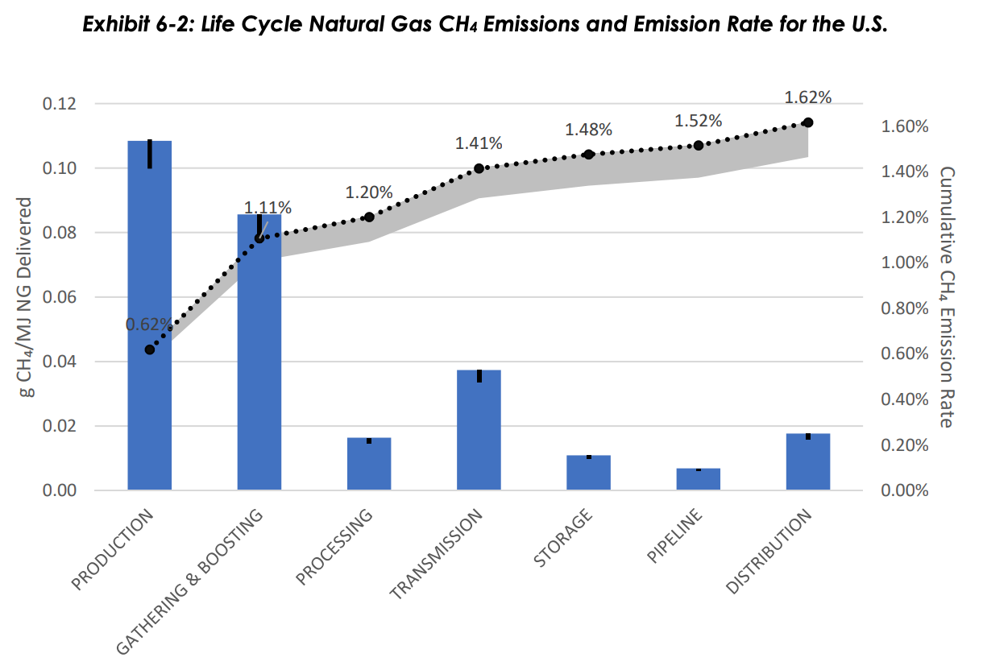
[Source: U.S. Department of Energy / National Energy Technology Laboratory]

By improving processes and infrastructure at key points upstream, Project Canary estimates U.S. gas producers could have cut 2019 methane and CO2 emissions by 42%. Levers for improvement include:
- Vapor recovery units, oxygen removal and leak monitoring at the storage tank
- Continuous monitoring via sensors and periodic monitoring via aircraft, satellites or drones to detect methane and avoid major leaks across the system
- Reliable air compressors and power pods and electric valve actuators to reduce emissions tied to pneumatics
- Eliminating or reducing the practices of venting and flaring gas during production

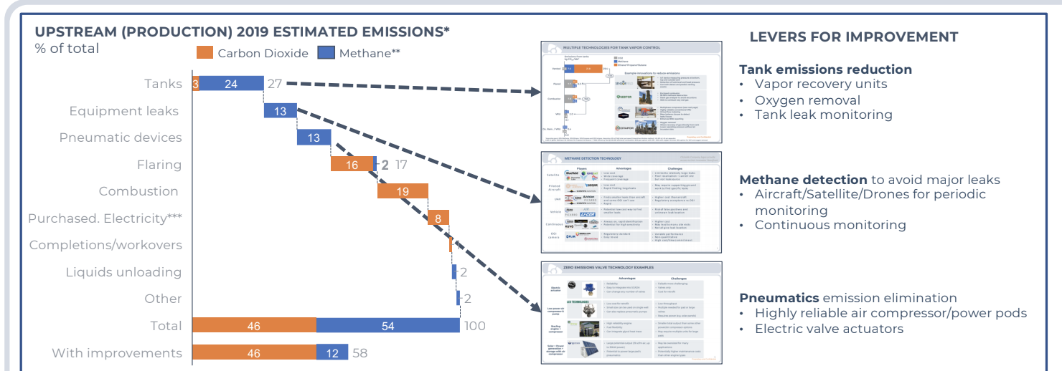
[Source: Andre Ditsch, Darcy Partners analysis 2021]
As noted, the U.N. Global Methane Assessment estimates there are readily available targeted control measures that can reduce projected anthropogenic methane emissions from oil and gas wells by more than 30 percent this decade. Many common emission sources are easily fixed, or at least the cause of remediation is clear. For example:
- Storage tank emissions can be reduced through closing thief hatches, vapor recovery units and oxygen removal
- Pneumatic devices can be replaced, sites can be electrified and compressors can be operated using compressed air
- The practice of flaring can be improved and eventually eliminated

On the topic of flaring, the Environmental Defense Fund found that around 11% of flares surveyed at oil and gas wells in the Permian Basin were either unlit or malfunctioning, resulting in an estimated 7% of Permian gas sent to flares escaping directly into the atmosphere. EDF also reported that 84% of Permian flaring could be avoided at no additional cost to producers. Flaring can be eliminated through design changes, such as ensuring adequate takeaway infrastructure is in place before bringing a well online, and operating decisions, such as shutting in a well until takeaway capacity is secure.

Measurements will be critical to achieving and proving the climate benefits. There have been significant discrepancies between methane emissions estimates reported to the EPA and measurements taken by independent scientists, satellites and nonprofit environmental organizations. The Environmental Defense Fund conducted research from 2012-2018 showing methane leaks in the U.S. were far greater than government estimates: 13 million metric tons of methane emitted by the oil and gas industry per year compared to the EPA estimate of 8 million tons.

That annually wasted gas is enough to fuel 10 million homes for a year and worth an estimated $2 billion.

Project Canary uses on-site sensors and algorithm technology to provide continuous monitoring that cuts the waste and reduces emissions. Through the continuous monitoring required for Project Canary’s TrustWell certification, gas producers have already caught and stopped methane leaks in minutes or hours, rather than the weeks or months it takes producers not monitoring continuously to catch these often unreported emissions.

These benefits can accrue at affordable costs.

The industry average methane emissions intensity for natural gas production is 0.45%, though it is almost certainly higher when considering undetected, uncounted emissions. For super emitters who ignore not only best but even basic practices for emissions controls, the rate is much higher. That compares to an emissions intensity of responsibly sourced gas that is closer to 0.04%.

Given the $18.10 price of CO2 in a recent CARB carbon market auction, the price to offset emissions from gas with industry-average methane intensity would be about 3.5 cents per MCF higher than responsibly sourced gas. That’s using the EPA’s 100-year time horizon to calculate the global warming potential of methane. Using the higher global warming potential estimate for methane based on the 20-year time horizon, the price to offset gas with industry-average methane intensity rises to 12 cents per MCF. And if the higher global warming potential estimate is paired with the $45-plus price of carbon in the EU ETS market, the price to offset industry-average gas would be nearly 31 cents per MCF.

Certified gas transactions that we at Project Canary have been made aware of are occurring at prices well below the CARB carbon price. For a transaction in the low, single-digit cent premiums, for a gas purchase of 100,000 MMBTUs/day serving 500,000 customers, the pass-through cost to the end customer would represent $0.97/household/year at a premium of 1 cents/MMBTU and occur at carbon abatement price of $2.00/ton carbon dioxide equivalent (assuming a 100-year global warming potential for methane of 25). At a premium of 5 cents/MMBTU, the pass-through cost to the customer would represent $3.65/household/year and occur at a price of $9.98/ton carbon dioxide equivalent.

Utilities are already making public commitments to help reduce upstream gas emissions that fall outside of their own reported emissions through procurement of responsibly sourced gas.

For example, SoCalGas in its 2045 net-zero climate commitment said, “By 2025, we plan to increase procurement of responsibly sourced gas,” which they define as natural gas procured from suppliers that proactively manage methane emissions across their entire gas supply chain. Puget Sound Energy in its “Beyond Net Zero by 2045” report states a goal to “go beyond reducing emissions that we report by partnering with customers and industry to reduce carbon across sectors and across the state.” The company says its aspiration is to transform its natural gas distribution business through “renewable natural gas, new technologies and policies that enable transformation while supporting reliability and affordability for PSE customers.”

Conclusion

Cost-effective and technologically mature solutions exist to reduce emissions that are and can be recognized by the market and regulators. Critical to the implementation of these programs are independent verification and measurement, most notably through direct, on-site sensing. While commitments have been made and companies are making investments, regulatory barriers remain to implementation at scale. Regulators can enable technologically feasible and cost-effective climate progress in the natural gas supply system through sound policy.

“Utilities’ path to a carbon-free energy system by 2050,” Smart Electric Power Alliance, https://sepapower.org/utility-transformation-challenge/utility-carbon-reduction-tracker/
“How and when states plan to reduce carbon emissions,” American Public Power Association, March 2, 2020, https://www.publicpower.org/periodical/article/how-and-when-states-plan-reduce-carbon-emissions
https://dcpsc.org/CMSPages/GetFile.aspx?guid=79212452-fd2b-42c2-ad6d-f97ab6ca2ef4
https://www.mass.gov/news/department-of-public-utilities-opens-investigation-assessing-future-of-natural-gas-in
https://www.eia.gov/energyexplained/natural-gas/use-of-natural-gas.php
https://www.c2es.org/content/natural-gas/
https://www.edf.org/media/through-turbulent-year-edf-data-show-permian-oil-and-gas-operators-consistently-failed-keep
https://www.edf.org/climate/methane-studies
https://www.socalgas.com/sites/default/files/2021-03/SoCalGas_Climate_Commitment.pdf
https://www.pse.com/en/pages/together

