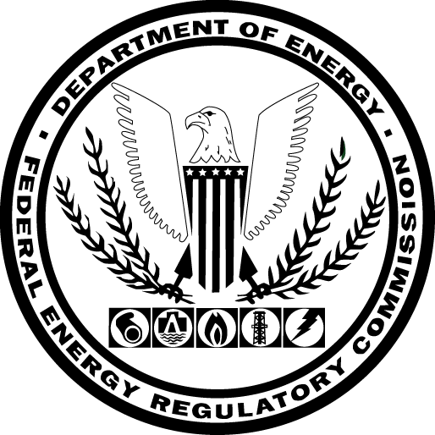

Conference on the Five-Year Review of the Oil Pipeline Index

Federal Energy Regulatory Commission Headquarters
Docket No. RM15-20-000
July 30, 2015

Agenda

The purpose of the conference is to gain an understanding of the positions of the parties in advance of the filed comments in this proceeding. At the conference, the panelists listed below will give brief presentations regarding the index level proposed in the Commission’s June 30, 2015 notice of inquiry and any alternative methodologies for calculating the index level. Each presenter will be allowed 10 minutes.

2:00pm – 2:10pm Opening Remarks

2:10pm – 3:00pm Panelist Presentations

Ramsey Shehadeh, NERA Economic Consulting, on behalf of the Association
of Oil Pipe Lines (with a brief introduction from Steven Kramer, Senior Vice President and General Counsel of the Association of Oil Pipe Lines)
Steven Adducci, Venable LLP, on behalf of the Valero Marketing and Supply
Company
James Holt, Betts & Holt LLP, on behalf of the Canadian Association of
Petroleum Producers
Richard Powers, Venable LLP, on behalf of the Airlines for America (A4A)
and the National Propane Gas Association
Katherine Edwards, Edwards & Floom, LLP, on behalf of the Liquids Shippers
Group

3:00pm – 3:55pm Discussion
3:55pm – 4:00pm Closing Remarks

