Overview of Comments
Michael Hummel, Associate General Manager & Chief Power System Executive
Submitted to the
Federal Energy Regulatory Commission
In Advance of the
February 25, 2015 Technical Conference On
the Environmental Protection Agency’s Clean Power Plan
Docket No. AD15-4
February 19, 2015
Salt River Project (SRP) apreciates the opportunity to participate in this technical conference and present its concerns regarding the reliability impacts of the Environmental Protection Agency’s (EPA) proposed Clean Power Plan. SRP is a public power entity serving the needs of approximately one million electric customers in the Phoenix Metropolitian area. SRP also provides bulk water to municipal and agricultural entities in the Phoenix area.
SRP has already taken material action to address CO₂ emissions. SRP’s elected board has added significant amounts of renewable energy and other sustainable resources to its resource portfolio since 2004, and was in the process of establishing additional CO₂ reduction goals when EPA announced the proposed rule.
While SRP understands EPA’s desire to address CO₂ emissons from existing power plants, the proposed rule as currently drafted places an inequitable burden on the State of Arizona to achieve CO₂ reductions.
EPA’s proposed final goal for Arizona would require a 52% reduction in CO₂ emissions intensity from the proposed program baseline year of 2012. Even more problematic is EPA’s proposed interim goal for Arizona, which would require Arizona to achieve 90% of the total reductions required by EPA as early as 2020. These goals are unrealistic and place Arizona at risk for significant reliability concerns.
Reductions Required in Arizona
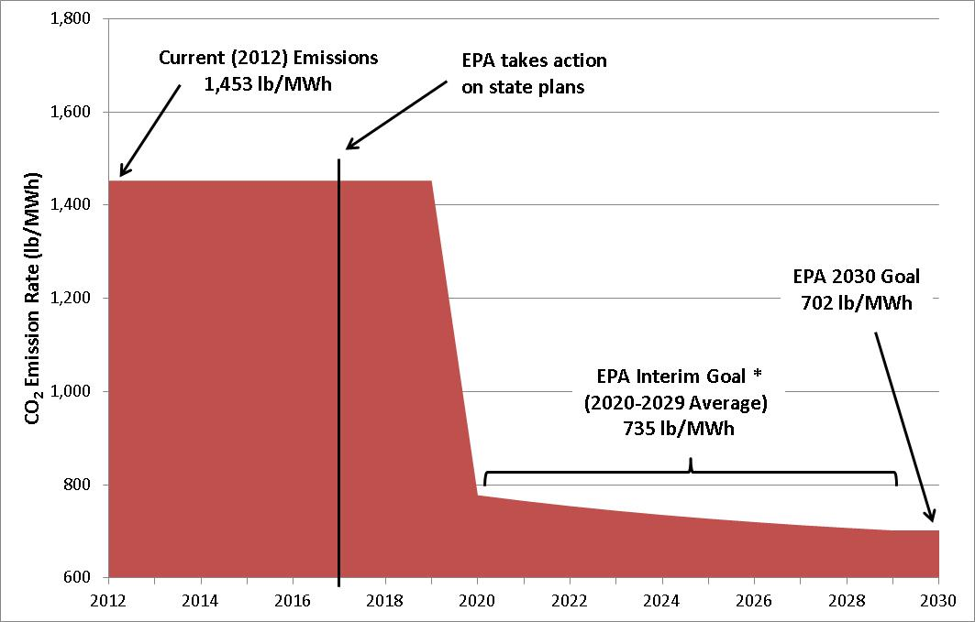
EPA’s goal calculations presume that Arizona will achieve approximately 80% of its 2030 goal by 2020 from application of EPA’s Building Block 2 alone. Under EPA’s application of Building Block 2, all Arizona-based coal generation – 3,800 MW – will go away in 2020 and be replaced with existing natural gas generation. Unfortunately, this assumption is not supported by an analysis of generation capacity available to meet summer peak demand, transmission constraints, or natural gas pipeline capacity. EPA’s overreliance on Building Block 2 eliminates any flexibility the rule intended to provide to utilities seeking to comply with the rule.
EPA’s assumptions also overstate the ability of Arizona to meet its peak needs through the use of generation resources located in other states. The Integrated Planning Model used by EPA to assess the reliability and cost impacts of the current rule assumes that Arizona can rely significantly on imported capacity from out-of-state to meet reliability requirements and Arizona’s stringent CO₂ goals.
Arizona has historically been a net exporter of energy to the rest of the west. As depicted in the slide below prepared by the Brattle Group, the EPA modeling for the Clean Power Plan assumes that Arizona will become a net importer within 4 years and a significant net importer by 2030 to meet its energy needs. This is a drastic change in resource utilization, and SRP is concerned that this EPA timeline will challenge SRP’s ability to reliably serve load.
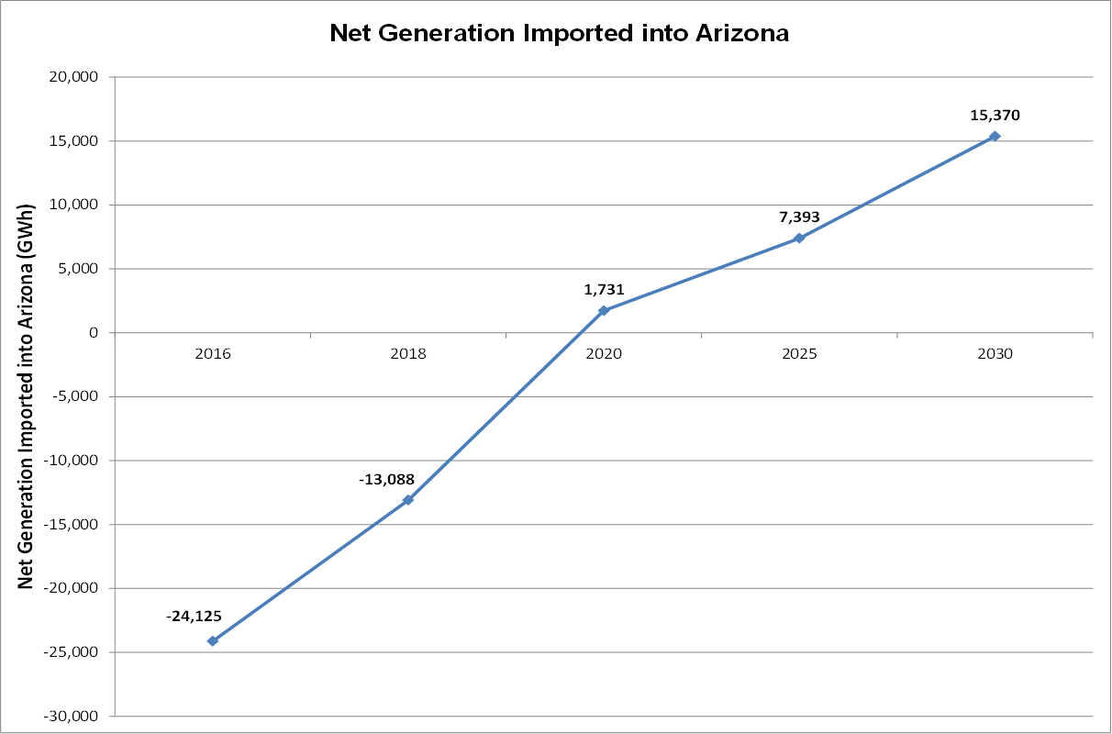
EPA modeling also indicates that Arizona’s needs could be served by resources located in the Pacific Northwest and Southern California as depicted in the graphic below also prepared by the Brattle Group. This conclusion does not take into account known transmission constraints and inadequate generation capacity.
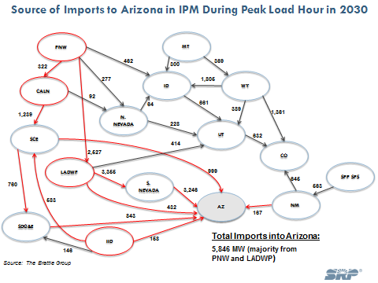

Given EPA’s assumptions about Arizona’s future reliance on natural gas generation, SRP expects additional natural gas infrastructure will be needed to meet demand driven by Clean Power Plan compliance. Two pipelines currently provide service to Arizona’s gas plants. One of those pipelines is operated by El Paso Natural Gas Company and the other is operated by Transwestern Pipeline Company. These systems, shown below, have limited excess capacity available and are nearly fully subscribed in the winter months.
Arizona and New Mexico Regional Gas Transportation Pipelines
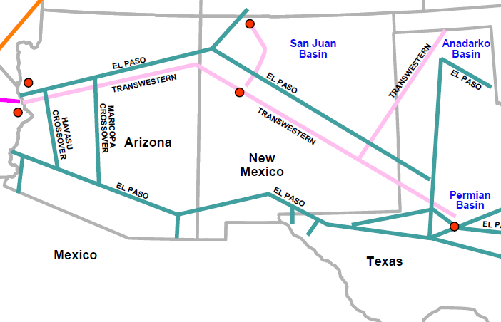
The breadth of EPA’s proposed rule means that Arizona utilities will need to compete for natural gas supply for natural gas generation with shippers from California, New Mexico, and Texas. Furthermore, recent increases in exports to Mexico raise additional concerns as to the feasibility of securing adequate natural gas supply in the near term.
In addition to expanding natural gas pipeline infrastructure, additional electric transmission capacity will be needed. In Arizona, more than 80% of the land is owned by federal and state governments and tribal nations. Siting and permitting of electricity and gas transmission infrastructure on federal or tribal land is subject to many processes and procedural requirements for compliance that can threaten timely completion of these projects.
EPA’s plan also contemplates that Arizona will construct new natural gas generation capacity or upgrade existing natural gas capacity. EPA has recently proposed to revise the National Ambient Air Quality Standards (NAAQS) for ozone to within the range of 65-70 ppb. Preliminary modeling by the Western States Air Resources Council (WESTAR) suggests that any revision to the current standard would create new nonattainment areas in the state. This could severely limit the ability to construct any new natural gas capacity. Again, this presents a challenge to continued reliable electric service in Arizona.

Modeled Ozone Concentrations in Arizona with Lower Ozone Standards
>70 ppb | >65 ppb | >60 ppb
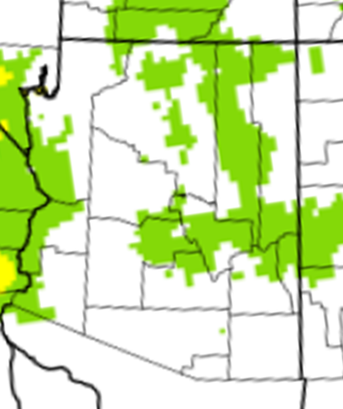 | 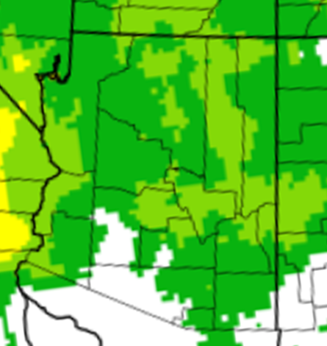 | 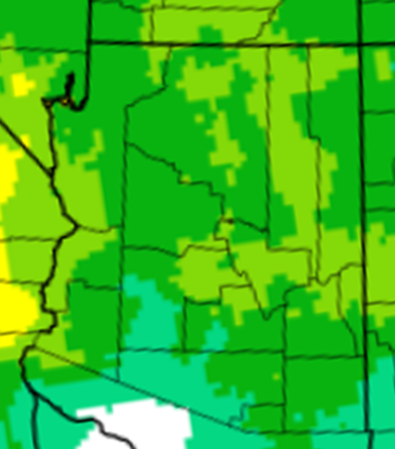

SRP fully recognizes that the FERC is not an air regulator. We appreciate and support the role that FERC is playing to address reliability concerns with the proposed rule. The Clean Power Plan as currently drafted will have a disproportionate impact on Arizona and threatens our ability to reliably maintain the electric grid. We believe FERC should play a role shaping the final rule to address these concerns.
There are solutions available to moderate the impact of the rule on Arizona while still achieving meaningful reductions in carbon emissions intensity. Rather than assuming all re-dispatching of coal to gas would occur in 2020, EPA should account for the “remaining useful life” of coal-fired power plants in establishing interim and final goals by adjusting the Building Block 2 re-dispatch schedule as follows:
- The default re-dispatch date is 40 years after startup date, or 2020, whichever is later.
- For units that have installed a major pollution control retrofits prior to issuance of the final CPP, the default re-dispatch date is 20 years after start of operation following addition of the major pollution control retrofit, or 2020, whichever is later.
- For units that have been issued a permit incorporating a commitment to cease burning coal before the effective date of the final rule, the re-dispatch date is the date of the commitment.
In addition, EPA should allow states to set the Clean Power Plan interim goals, and the agency should apply an appropriate natural gas emission rate that is no lower than the limit proposed for new sources under Section 111(b) of the Clean Air Act.
If EPA implements these proposed solutions to address the interim and final goals, the rule would not threaten reliability in Arizona and the impact to SRP’s customers will be approximately $2.4 billion less than if SRP were forced to implement the rule as proposed by EPA. EPA would also still meet its environmental gols. Arizona would reduce its carbon intensity by 34%. This is in line with the nationally stated goal of a 30% reduction in carbon intensity from 2005 by 2030.
Additional steps FERC should consider taking:
- Support the North American Electric Reliability Corporation’s (NERC) analysis of EPA’s proposal and any recommendations that NERC may offer.
- Support solutions like the Arizona proposal that would give states time and greater discretion in implementing the rule.
- Expedite approvals for new infrastructure necessary to implement the final rule.
- Encourage EPA to incorporate a detailed and thorough reliability analysis in the final rule prior to implementation.

